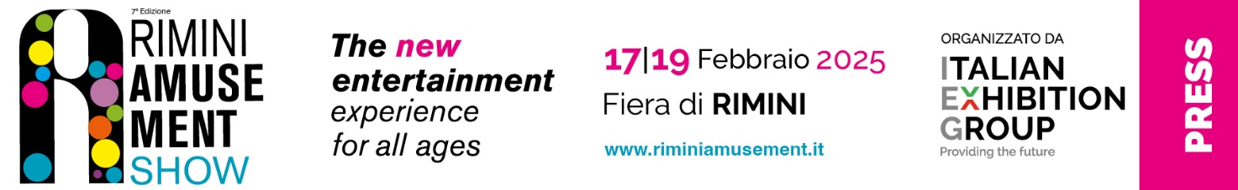

press release no. 6

The International Sports Pinball Tournament RETURNS AT
RAS – RIMINI AMUSEMENT SHOW!

From February 17 to 19, the 4th edition of the JJP Pinball Fest Enada tournament by Luxury Games will take place at Rimini Expo Centre during Enada Primavera 2025 and the 7th edition of RAS.

Rimini, 30 January 2025 - Over the three days of Enada Primavera 2025 and RAS - Rimini Amusement Show (running from February 17 to 19 at Rimini Expo Centre), the 4th edition of JJP Pinball Fest Enada by Luxury Games returns to the scene. This sports pinball tournament, organised by Luxury Games - the exclusive distributor of the American manufacturer's pinball machines in Italy - in collaboration with the amateur sports association IFPA Italia, offers the chance to earn points for the World Pinball Player Rankings (WPPR). It also marks the third stage of the ICS 2025 - Italian Championship Series National Circuit.

The competition, which will conclude with the award ceremony on Wednesday, February 19, will take place in the Luxury Games space (Hall D3, stand 088). It will be played exclusively on Jersey Jack Pinball machines, allowing professional players, as well as amateurs and budding enthusiasts, to compete on the most sought-after versions of the best games crafted by the renowned pinball brand. Participants will have the chance to win various prizes and earn valuable points for the ranking.
Rimini will host five Jersey Jack pinball machines: 'Toy Story,' 'The Godfather,' 'Guns 'n Roses,' 'Elton John,' and 'Avatar,' all in collector's edition. Additionally, several pinball machines will be available for free play.

In the Main Tournament, along with the WPPR ranking points, the following prizes will also be up for grabs*:
1st place: TV
2nd place: Tablet
3rd place: Smartphone

Programme

Monday 17 February: Side Tournament (JERSEY JACK WARM-UP 2025)
• 10:00 AM: Check-in
• 10:30 AM: Qualifying Round (Part 1)
• 1:30 PM: Break
• 2:00 PM: Qualifying Round (Part 2)
• Approximately 4:30 PM: any potential tiebreakers
• Approximately 5:00 PM: the final phase
• Approximately 5:30 PM: award Ceremony

Tuesday 18 February: Main Tournament (4th EDITION JERSEY JACK PIN FEST AT ENADA 2025)
• 10:00 AM: Check-in
• 10:30 AM: Qualifying Round (Part 1)
• 1:30 PM: Break
• 2:00 PM: Qualifying Round (Part 2)
• Approximately 5:30 pm: Any potential tiebreakers

Wednesday 19 February: Main Tournament (4th EDITION JERSEY JACK PIN FEST AT ENADA 2025)
- 10:00 AM: Check-in
- 10:30 AM: The final phase
- Approximately 1:30 PM: Award Ceremony

To learn more about the double tournament and to access the regulations and all relevant information, please visit the official website of Ifpa Italia: www.ifpaitaia.it

*(The prizes will be awarded to the winners within twenty days of the event's conclusion)

ABOUT ENADA 2025
Date: 17-19 February 2025; organiser: Italian Exhibition Group S.p.A., in collaboration with SAPAR; edition: 37th; recurrence: annual; info: https://www.enada.it/

ABOUT RAS 2025
Date: 17-19 February 2025; organiser: Italian Exhibition Group S.p.A., in collaboration with SAPAR; edition: 7th; recurrence: annual; info: https://www.riminiamusement.it/

ITALIAN EXHIBITION GROUP PRESS CONTACTS
head of media relation & corporate communication: Elisabetta Vitali; press office manager: Marco Forcellini, Pier Francesco Bellini; international press office coordinator: Silvia Giorgi; press office coordinator: Luca Paganin; press office specialist: Nicoletta Evangelisti, Mirko Malgieri: media@iegexpo.it

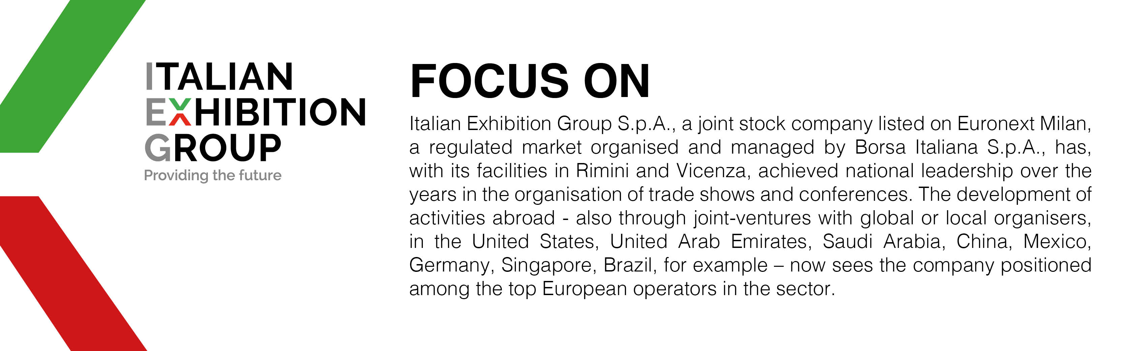
This press release contains forecast elements and estimates that reflect the management’s current opinions (“forward-looking statements”), particularly regarding future management performance, realization of investments, cash flow trends and the evolution of the financial structure. For their very nature, forward-looking statements have a component of risk and uncertainty, as they depend on the occurrence of future events. The effective results may differ (even significantly) from those announced, due to numerous factors, including, only by way of example: food service market and tourist flow trends in Italy, gold and jewellery market trends, green economy market trends; the evolution of raw material prices; general macroeconomic conditions; geopolitical factors and evolutions in the legislative framework. Moreover, the information contained in this release does not claim to be complete, and has not been verified by independent third parties. Forecasts, estimates and objectives contained herein are based on the information available to the Company as at the date of this release.

